Media Asset Management (MAM) is a system or process used to store, organize, manage, and distribute digital media files such as video, audio, images, graphics, and related metadata.
It’s widely used in broadcasting, media, entertainment, OTT platforms, and corporate environments where large volumes of media content need to be handled efficiently.

🔑 Key Functions of MAM
- Ingesting
  - Bringing media files into the system from cameras, storage devices, cloud, or live feeds.
- Cataloging & Metadata Management
  - Tagging files with metadata (title, description, creator, time, rights info, etc.) so content is easily searchable.
- Storage & Organization
  - Storing media in centralized storage (on-premises or cloud) in an organized manner for quick access.
- Search & Retrieval
  - Advanced search (using metadata, AI, facial recognition, speech-to-text, etc.) to find assets quickly.
- Editing & Workflow Integration
  - Integration with editing tools (Adobe Premiere, Avid, Final Cut, etc.) for smooth creative workflows.
- Access Control & Rights Management
  - Setting permissions (who can view, edit, publish, or archive).
- Distribution & Publishing
  - Delivering content to broadcast systems, OTT platforms, YouTube, or social media.
- Archiving & Preservation
  - Moving older or unused media into long-term storage while keeping it retrievable.

⚙️ Example Use Cases:
- TV Broadcasters → Store and reuse past shows, ads, news footage.
- OTT Platforms (Netflix, Hotstar, Prime Video) → Manage thousands of shows and movies with metadata for recommendations.
- Corporate Media Teams → Store training videos, ads, and marketing materials.
- Sports Broadcasting → Quick retrieval of highlights, replays, and historic footage.

Use Cases of MAM
- Broadcast & TV Channels → Manage shows, ads, promos, and news archives.
- OTT Platforms → Handle huge libraries (movies, series) with metadata for search/recommendations.
- Sports → Instant highlights, replays, and archives of past matches.
- Advertising Agencies → Reuse campaigns and brand assets.
- Corporates → Store training, HR, marketing, and CEO townhall videos.
- Film & Post-Production → Secure raw footage, edits, and VFX workflows.
- News Agencies → Archive and retrieve decades of global news footage.
- Education/E-Learning → Manage lectures and learning content.
- Government/Public Sector → Preserve speeches, cultural events, historical footage.
- Digital Publishers → Repurpose content across YouTube, Instagram, TikTok, etc.

VAM vs DAM vs MAM

1. DAM (Digital Asset Management)
- Scope: Manages all types of digital assets (documents, images, logos, presentations, PDFs, videos, audio).
- Focus: General-purpose content library for marketing, sales, and corporate teams.
- Users: Marketing teams, design teams, corporate communications.
- Example: Storing company logos, brand guidelines, images, product videos, presentations.

2. MAM (Media Asset Management)
- Scope: Specialized in rich media files (video, audio, images, graphics) at enterprise scale.
- Focus: Media-heavy workflows → ingest, catalog, edit, distribute, archive.
- Users: Broadcasters, OTT platforms, production houses, sports, news agencies.
- Example: Netflix managing 4K movie files with metadata for streaming & recommendations.

3. VAM (Video Asset Management)
- Scope: Subset of DAM, but focused only on video (storage, cataloging, editing, distribution).
- Focus: Video-centric workflows → especially short-form, marketing, and corporate use.
- Users: Marketing agencies, training teams, social media publishers.
- Example: A company storing training videos and marketing video ads in one system.

⚡ Quick Comparison Table
Feature | DAM (Digital Asset Management) | MAM (Media Asset Management) | VAM (Video Asset Management)
Content Types | All digital assets (docs, PDFs, images, videos, logos) | Rich media (video, audio, images, graphics) | Only video assets
Focus | Branding, marketing, corporate docs | Broadcast, production, OTT, post-production | Video storage & publishing
Complexity | General-purpose | Advanced workflows (editing, metadata, rights, distribution) | Medium (video-centric)
Users | Marketing, corporate teams | Media houses, broadcasters, OTT, sports/news | Marketing, training, social teams
Example | Adobe Experience Manager DAM | Dalet, Viz One, Avid MAM | Wistia, Vimeo, Brightcove

Cloud Playout :

Cloud Playout" is a broadcasting and media term.
It means delivering TV channels, live streams, or video feeds directly from the cloud instead of using traditional on-premise playout servers.
👉 In simple words:
It’s like running a full TV channel (live + scheduled content + graphics + ads) directly from the cloud (AWS, Azure, GCP) and then distributing it to cable, satellite, OTT apps, or YouTube/Facebook.

Components of Cloud Playout (on AWS)
- Ingest / Source – Live feed, stored content (S3), or scheduled playlists.
- Processing & Scheduling – AWS MediaLive (for live) + Automation layer (3rd party or custom).
- Packaging – AWS MediaPackage.
- Storage – S3 (VoD) , MediaStore (live).
- Delivery – CloudFront for distribution.
- Monetization & Personalization – MediaTailor for Ads, SCTE-35 markers.

Key components:

Key Components of Cloud Playout

1. Content Ingest & Storage
- Ingest live feeds (satellite/IP contribution, RTMP, SRT, etc.).
- Upload VoD libraries (movies, series, promos, ads) to cloud storage (e.g., AWS S3, Azure Blob, GCP Bucket).
- Content metadata & asset management.

2. Playout Automation & Processing & Scheduling
- Software to schedule playlists, programs, commercials, promos.
- Handles time-based scheduling, repeat loops, and last-minute changes.
- Ensures broadcast continuity 24/7.

3. Media Processing (Encoding/Transcoding)
- Converts content into required formats (MPEG-TS, HLS, DASH).
- Adaptive bitrate (ABR) encoding for OTT platforms.
- Supports multiple resolutions (SD, HD, 4K).

4. Graphics & Branding
- Channel logo insertion.
- Tickers, lower-thirds, clocks, weather updates.
- Dynamic graphics (live score overlays, stock updates).

5. Ad Insertion & Monetization
- SCTE-35/SCTE-104 markers for ad breaks.
- Dynamic Ad Insertion (DAI) / Server-Side Ad Insertion (SSAI).
- Targeted ads per region/device.

6. Channel Output / Packaging
- Output in linear TV formats (MPEG-TS for cable/satellite).
- OTT-friendly formats (HLS, DASH, CMAF).
- Multiple DRM support (Widevine, PlayReady, FairPlay).

7. Delivery & Distribution
- Delivered via CDN (Akamai, CloudFront, Fastly).
- Multi-platform distribution: OTT apps, IPTV, DTH, YouTube, Facebook Live.
- Global reach with scalable delivery.

8. Monitoring & Compliance
- Real-time monitoring of audio, video, graphics, and ads.
- Compliance logging (as per regional broadcast laws).
- Automatic error detection & failover.

9. Disaster Recovery (DR) & Redundancy
- Backup playout channels in different cloud regions.
- Failover from on-prem to cloud in emergencies.
- 24/7 high availability.

📌 In short:
Cloud Playout = Ingest + Storage → Scheduling → Encoding → Graphics → Ad Insertion → Packaging → Delivery → Monitoring → DR

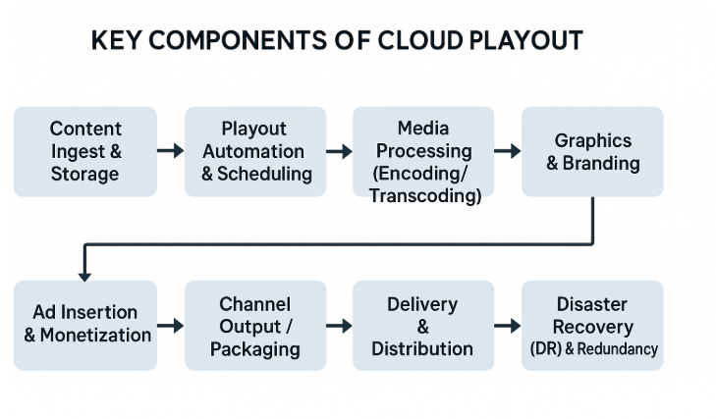

How Cloud Playout Works (Flow):
- Content Ingest → Upload videos/libraries to cloud storage (S3, GCP bucket, Azure).
- Schedule & Playlist → Use playout automation software (e.g., Amagi CloudPORT, Harmonic VOS, AWS MediaLive).
- Processing & Encoding → Transcoding into different formats/resolutions.
- Playout & Graphics → Real-time rendering of logos, tickers, EPG.
- Packaging → HLS, DASH, MPEG-TS, RTMP, etc.
- Delivery → CDN (CloudFront, Akamai) sends to end-users.

Media Asset Management (MAM)
- Focus: Organizing, storing, and managing media files (video, audio, images, metadata).
- Main Role: Acts like a media library for broadcasters and OTT platforms.
- Functions:
  - Ingest & catalog media assets.
  - Metadata tagging & search.
  - Workflow automation (review, approval, QC).
  - Version control & archive.
👉 Example: If a broadcaster has 10,000 hours of content, MAM helps them find, manage, and prepare content before it’s aired.

🔹 Cloud Playout
- Focus: Delivering a TV/OTT channel directly from the cloud.
- Main Role: Acts like a virtual broadcast control room in the cloud.
- Functions:
  - Schedule playlists & programs.
  - Insert graphics/logos.
  - Handle live + pre-recorded feeds.
  - Package & distribute to OTT, DTH, cable, social media.
👉 Example: Once content is managed in MAM, it is sent to Cloud Playout for actual broadcasting.

⚖️ Key Difference
- MAM = Content Management (preparation & organization).
- Cloud Playout = Content Delivery (channel output & distribution).
✅ They work together:
- Content stored & organized in MAM.
- Content scheduled & broadcast via Cloud Playout.

